**FRESHCO HYPERMARKET CAPSTONE**

# **ORDER LEVEL ANALYSIS**:

1. **Key Delivery Zones**: HSR Layout, ITI Layout, and Harlur are consistently high-activity areas across all time slots, indicating significant commercial activity and population density.

2. **Peak Order Times**: Afternoons and Mornings have the highest order distribution volume across most areas, while overall activity is low during Late Nights.

3. **Steady Demand in Key Areas**: Despite lower overall activity during Late Nights, areas like HSR Layout and ITI Layout maintain steady demand.

4. **Order Growth**: HSR Layout shows the most significant increase in orders from January to September, with a rise of 1,534 orders. ITI Layout and Harlur also show substantial growth.

5. **Shifting Demand**: Some areas, such as Bomannahali - MicoLayout, have seen a decrease in orders, suggesting a shift in demand or increased competition.

6. **Delivery Charges**: The Late Night slot has the highest delivery charges relative to the product amount (14.15%), followed by the Night slot (7.75%). Other slots average around 5-6%.

7. **Discount Trends**: Night Slot has the highest average discount percentage (6.53%), while the Late Night Slot has the lowest (1.50%). August shows the highest overall discount percentage (12.81%).

8. **Discount Hotspots**: Bilekahalli offers the highest discounts across all slots, especially at night (29.73%). Jayanagar also shows significant discounts during the evening slot (35.61%).

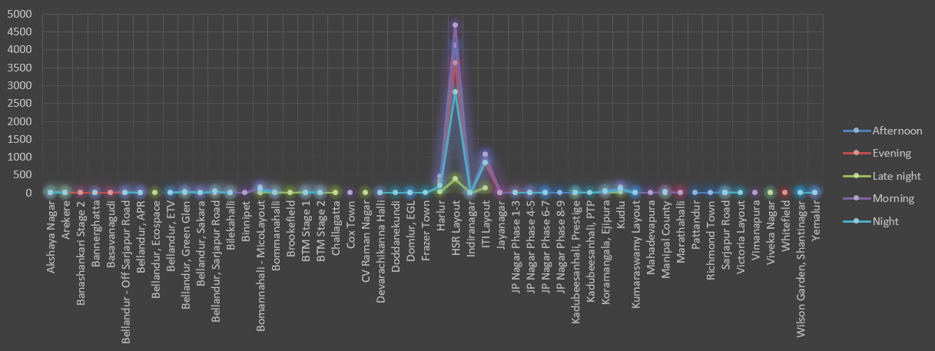Figure 1 : order distribution at slot and delivery area level

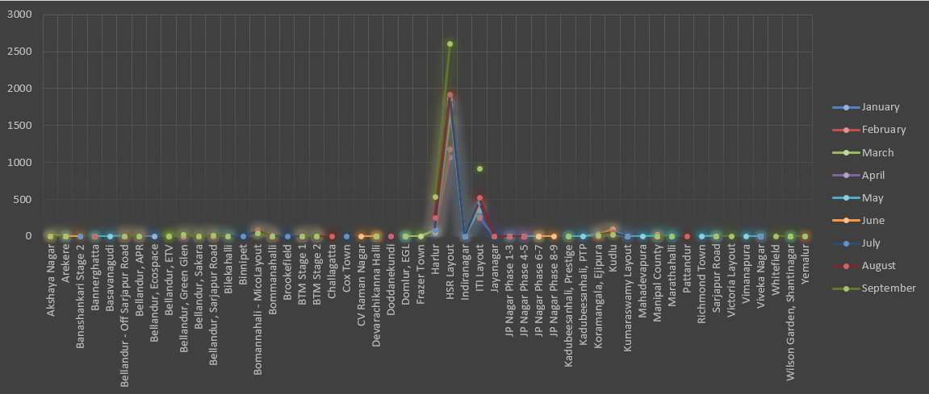Figure 2 : areas having highest increase in monthly orders (from Jan to Sep) in absolute orders

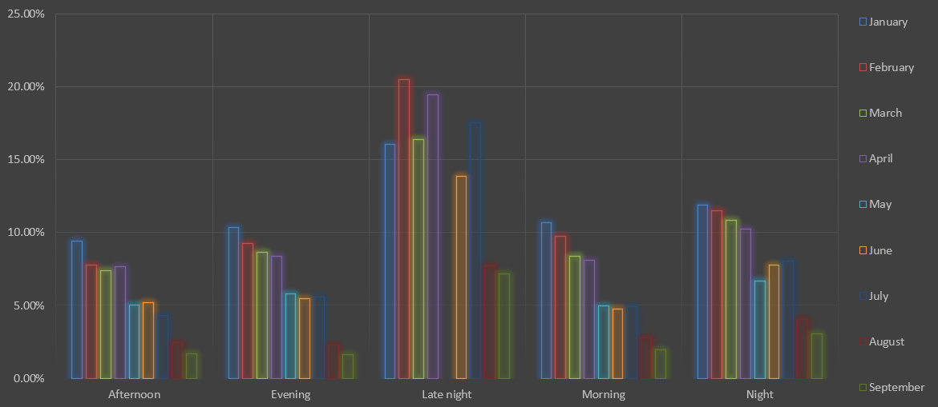Figure 3 : delivery charges as a percentage of product amount at slot and month level

Figure 4 : discount as a percentage of product amount at slot and month level

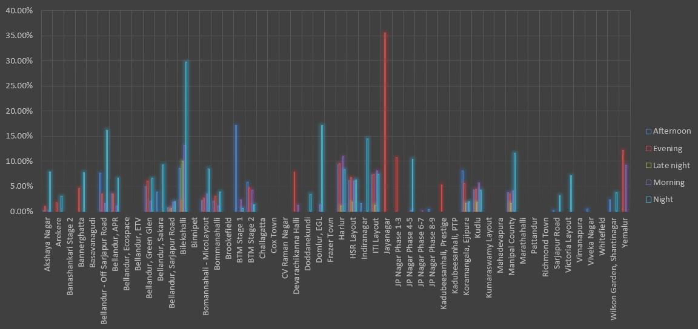Figure 5 : discount as a percentage of product amount at drop area and slot level

# **COMPLETION RATE ANALYSIS:**

1. **Sunday Performance**: Sunday has the highest overall completion rate, with the evening slot reaching 100%.
2. **Late Night Variability**: The Late Night slot shows variability, with some days like Wednesday and Saturday reaching 100%, but others, particularly Monday and Friday, showing lower rates.
3. **Afternoon Slot Dominance**: The Afternoon time slot has the highest average completion rate at 99.77% across all days.
4. **High-Performing Areas**: Areas such as Akshaya Nagar, Arekere, Bannerghatta, Basavanagudi, and Bilekahalli consistently achieve a 100% completion rate.
5. **Slightly Lower Performing** **Areas**: Bellandur (99.25%), Green Glen (99.25%), Bomannahali - MicoLayout (99.27%), Harlur (99.69%), and ITI Layout (99.59%) have slightly lower completion rates but still perform strongly.
6. **Zero Completion Areas**: Cox Town and Whitefield have a 0% completion rate, indicating a significant issue in these areas.
7. **Order Size Efficiency**: Smaller order sizes (1 to 25 products) maintain a completion rate of 100.45%, showing high efficiency.
8. **Overall Slot Efficiency**: All time slots show a completion rate close to or above 99%, reflecting consistent efficiency in order fulfilment.

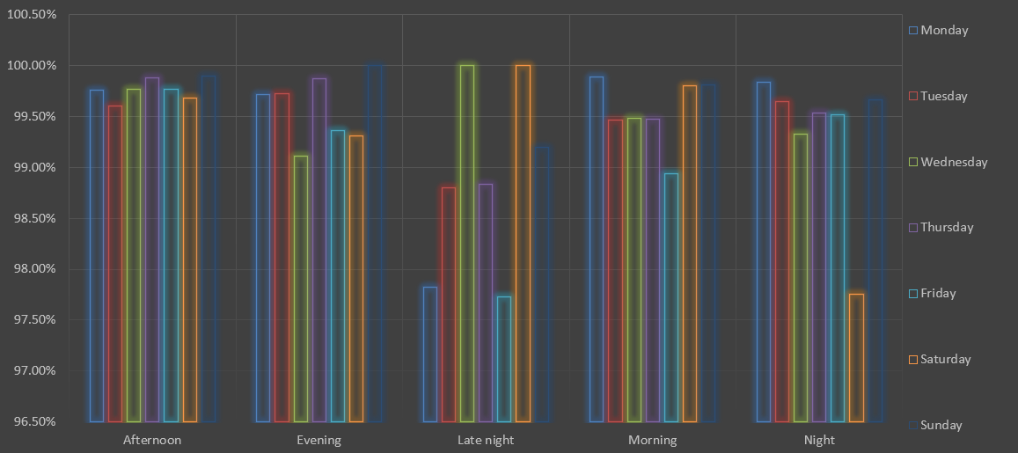Figure 6 : Completion rate at slot vs day of the week

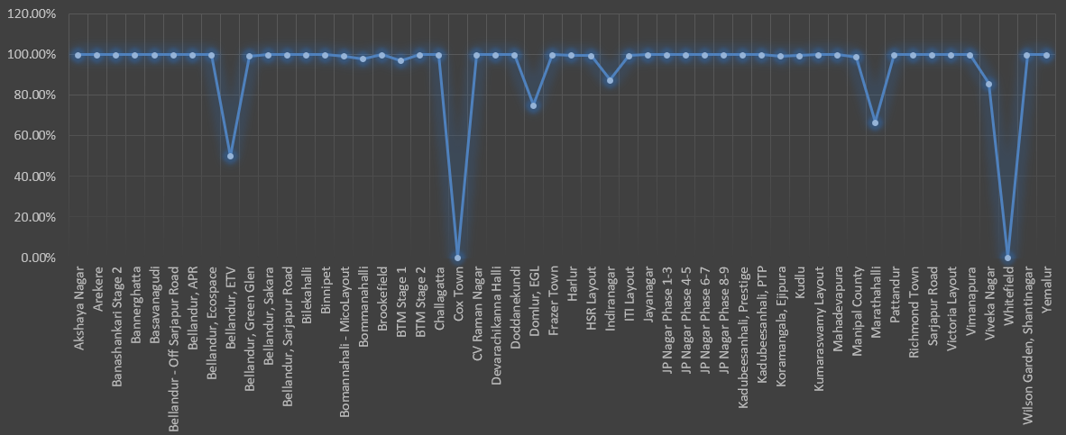Figure 7 : completion rate at drop area level

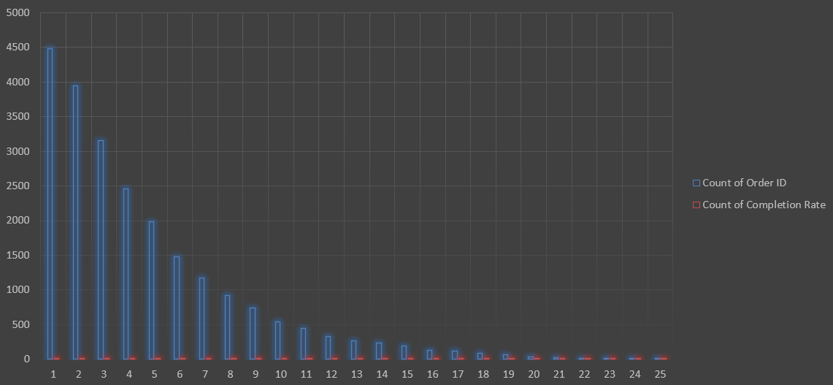Figure 8 : Completion rate at number of products ordered level

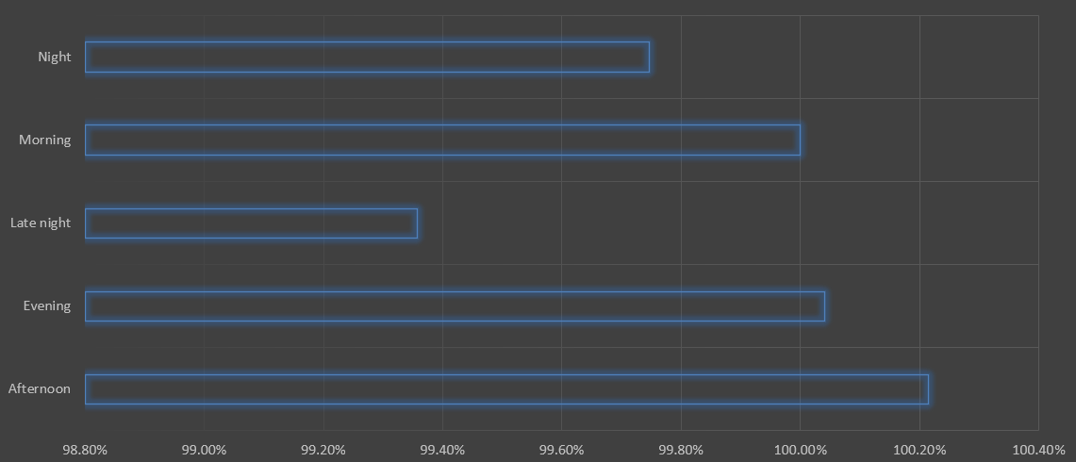Figure 9 :completion rate analysis at slot level

# **CUSTOMER LEVEL ANALYSIS:**

1. **Organic Leads Performance**: Organic Leads had the highest completion rate at 29.29%, and they also have the highest average LTV at 13,291.98.

2. **Google Effectiveness**: Google is the second most effective source, accounting for 22.43% of completion orders and has an average LTV of 12,948.84.

3. **Social Media Impact**: Among social media platforms, Snapchat had the lowest impact on completions (11.09%) and the lowest average LTV (3,075.14). Instagram (12.19%) and Facebook (11.47%) showed moderate impact with slightly higher LTVs.

4. **Offline Marketing Contribution**: Offline marketing accounted for 12.53% of completions with a moderate average LTV of 3,874.45.

5. **Significant Purchase**: The highest-priced purchase was made by user ID "APQ2413449," amounting to 6,397,125, highlighting the importance of high-value clients.

6. **Average Purchase Value**: Each client contributes an average purchase value of 52,009, showcasing the mean revenue generated by each customer.

7. **Aggregated LTV Performance**: September achieved the highest aggregated LTV at 28,174,665, with March and July also performing well. May had the lowest aggregated LTV at 16,728,973.

8. **Revenue Per Order**: Snapchat and Google led with the highest average revenue per order at 363.52 and 363.05, respectively. May had the highest average revenue per order (401.83), while September had the lowest (286.69).

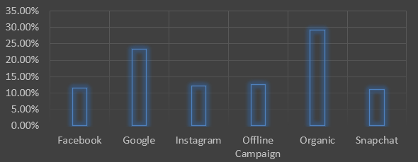Figure 10 : Completion rate at source level

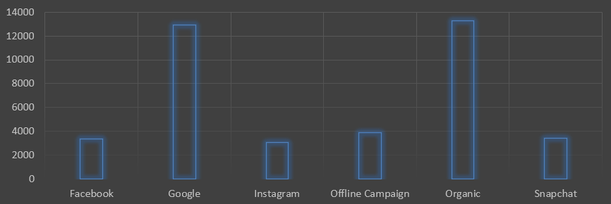Figure 11 : aggregated LTV at customer acquisition source level

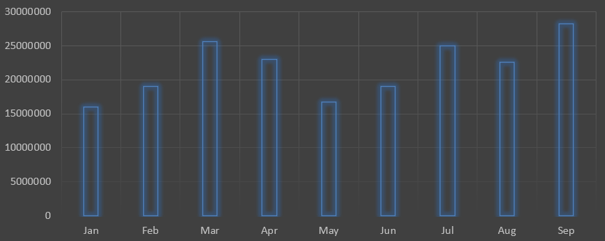Figure 12 : aggregated LTV at acquisition month level

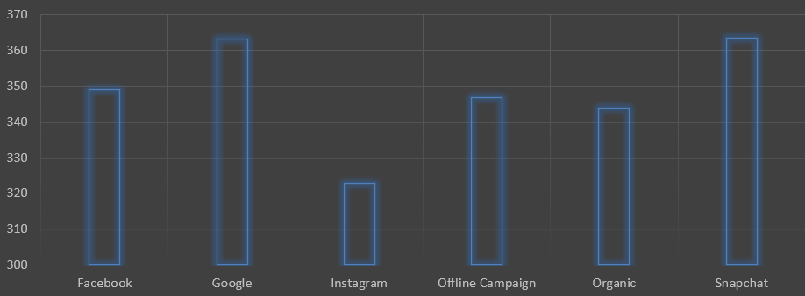Figure 13 : average Revenue per order at different customer acquisition source level

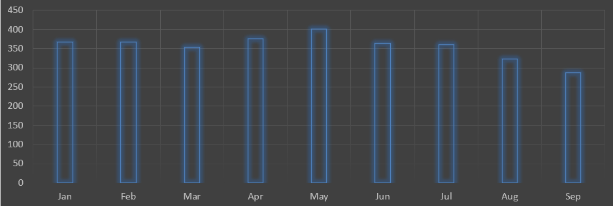Figure 14 :average Revenue per order at acquisition month level

# **DELIVERY ANALYSIS:**

1. **Monthly Delivery Time Variation**: Delivery times are slowest in May and fastest in February, with other months showing moderate variations.

2. **Area-Specific Delivery Times**: Areas like Mahadevapura experience significantly longer delivery times, while Bellandur, Ecospace, and HSR Layout have faster delivery times.

3. **Delivery Time by Slot**: The Late Night slot has the fastest average delivery time, while the Afternoon slot is the slowest. Evening, Night, and Morning slots are close to the overall average.

4. **Weekend vs. Weekday Delivery**: Weekends generally have slightly faster delivery times compared to weekdays, though this varies by month.

5. **Area-Specific Delivery Charges**: HSR Layout and ITI Layout have exceptionally high delivery charges, while areas like Victoria Layout and Pattandur have much lower charges.

6. **Delivery Charges by Time of Day**: Morning deliveries have the highest total delivery charges, indicating high demand, whereas Late Nights have the lowest charges due to reduced demand.

7. **Consistent Area Performance**: HSR Layout, ITI Layout, and Bellandur Green Glen consistently have earlier average delivery times.

8. **Areas with Late Deliveries**: Mahadevapura, Vimanapura, and Pattandur have notably late delivery times, while Whitefield and Cox Town have the earliest delivery times.

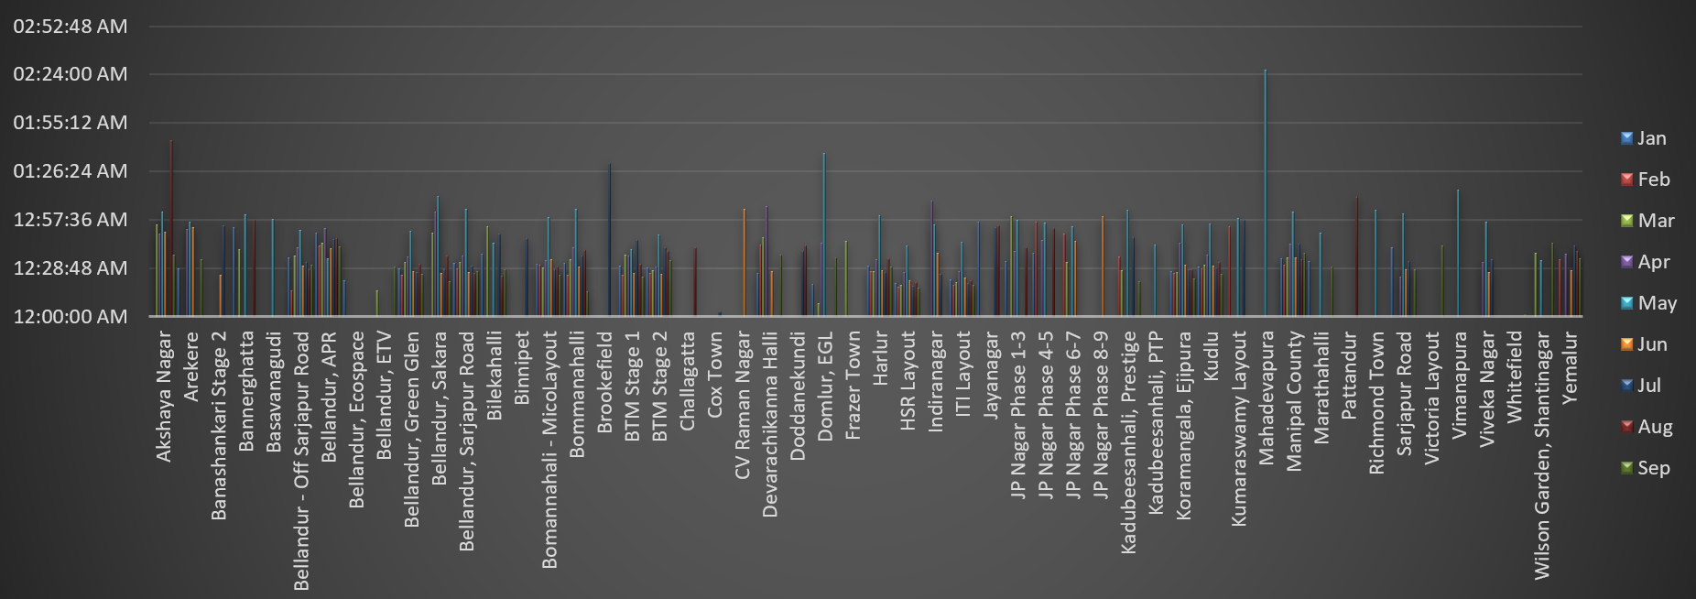Figure 15 : average overall delivery time at month and delivery area level

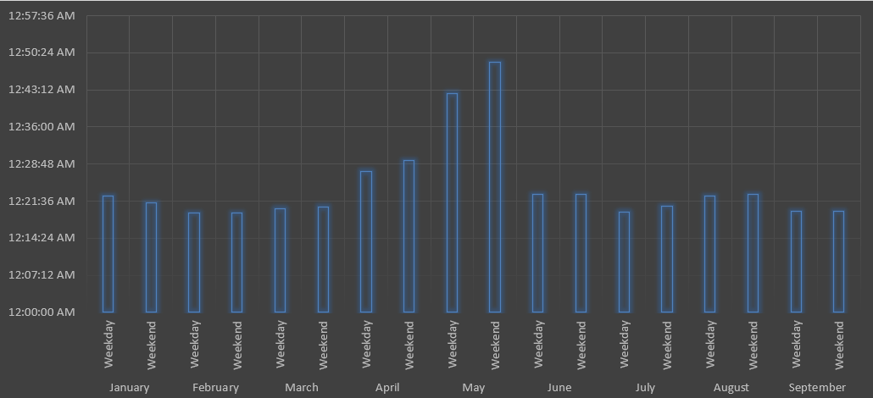Figure 16 : average overall delivery time at month and weekday/weekend level

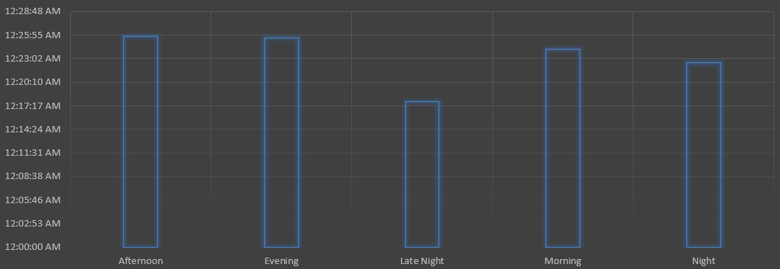Figure 17 : average overall delivery time at slot level. Refer to the definition of slot

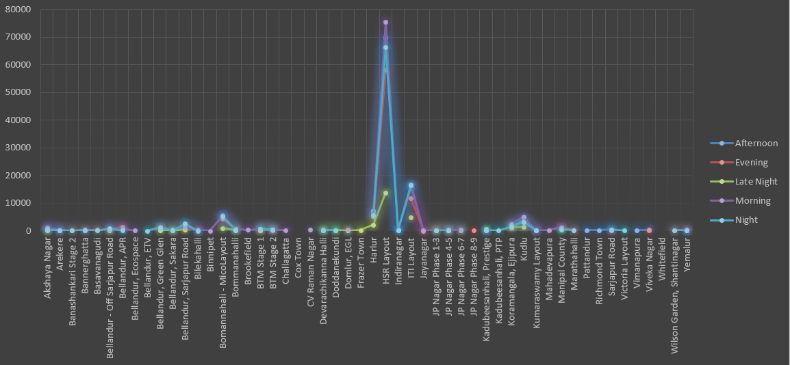Figure 18 : delivery charges with slot or delivery area

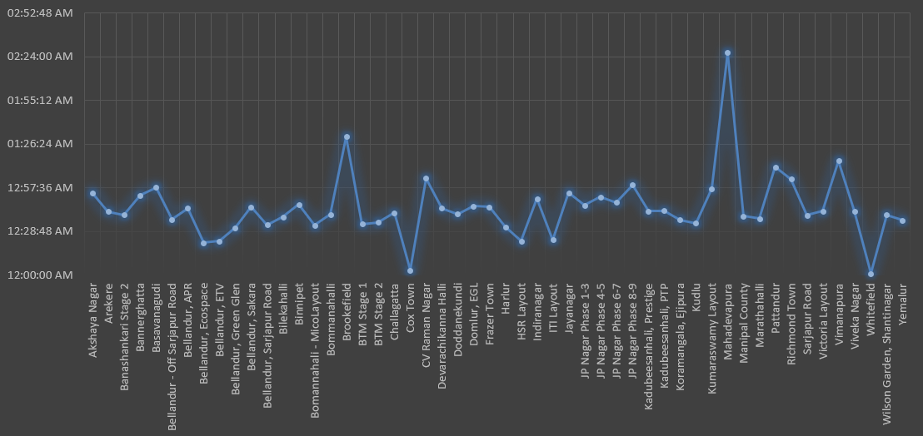Figure 19 : delivery time vs delivery area